**DAILY ONLINE ACTIVITIES SUMMARY**

|  |  |  |  |  |  |
| --- | --- | --- | --- | --- | --- |
| **Date:** | | **02/06/2020** | **Name:** | **JASLINE SHARON TAURO** | |
| **Sem & Sec** | | **4th sem, A Section** | **USN:** | **4AL18CS029** | |
| **Online Test Summary** | | | | | |
| **Subject** | **N/A** | | | | |
| **Max. Marks** | **N/A** | | **Score** | **N/A** | |
| **Certification Course Summary** | | | | | |
| **Course** | | **Trailhead basics** | | | |
| **Certificate Provider** | | **Sales force** | **Duration:** | | **4 HRS** |
| **Coding Challenges** | | | | | |
| **Problem Statement:**   1. Write a java program to count all the triplets such that sum of two elements equals the third element. 2. Write a Java Program to find total number of subarrays which start and end with the same element. | | | | | |
| **Status: DONE** | | | | | |
| **Uploaded the report in GitHub** | | | **YES** | | |
| **If yes Repository name** | | | <https://github.com/jaslinesharontauro/JAVA_Prgms> | | |
| **Uploaded the report in slack** | | | **YES** | | |

**Online Test Details: (Attach the snapshot and briefly write the report for the same)**

**Certification Course Details: (Attach the snapshot and briefly write the report for the same)**

**Coding Challenges Details: (Attach the snapshot and briefly write the report for the same)**

**1.CERTIFICATION COURSE DETAILS**

**Today I have done the Course named Trailhead Basics by Sales Force. Today I have learnt about Reports & Dashboards for Lightning Experience, How to Build a Data Model for a Recruiting App and To Create Reports and Dashboards for Sales and Marketing Managers. I have successfully completed all the Hands-on-challenges of all 12 modules and I have earned 12 badges.**

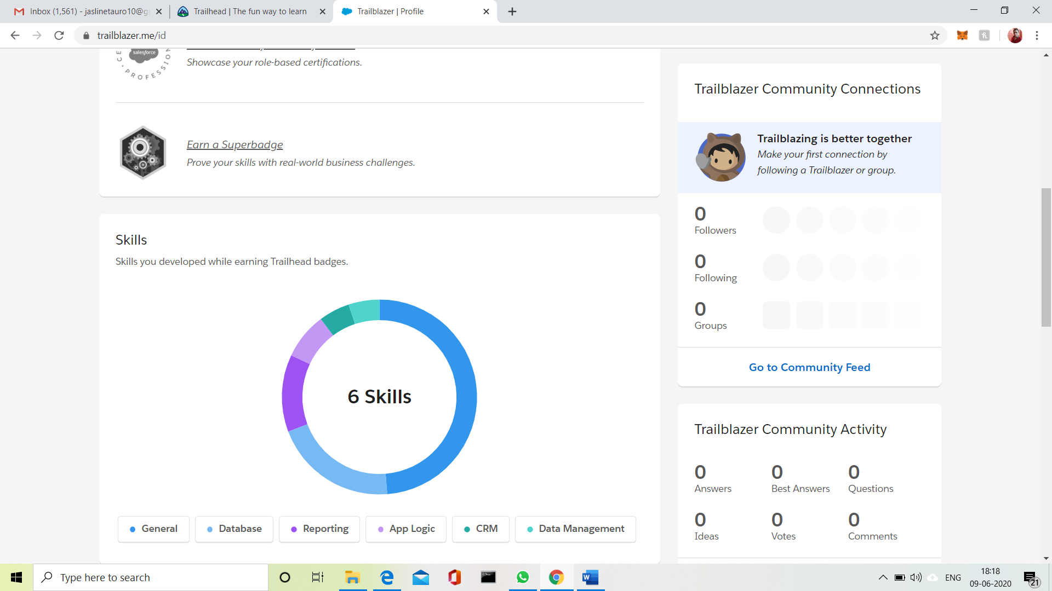



**3.CODING CHALLENGES DETAILS:**

Problem Statement 1:

 Write a java program to count all the triplets such that sum of two elements equals the third element.

Given an array of distinct integers. The task is to count all the triplets such that sum of two elements equals the third element.

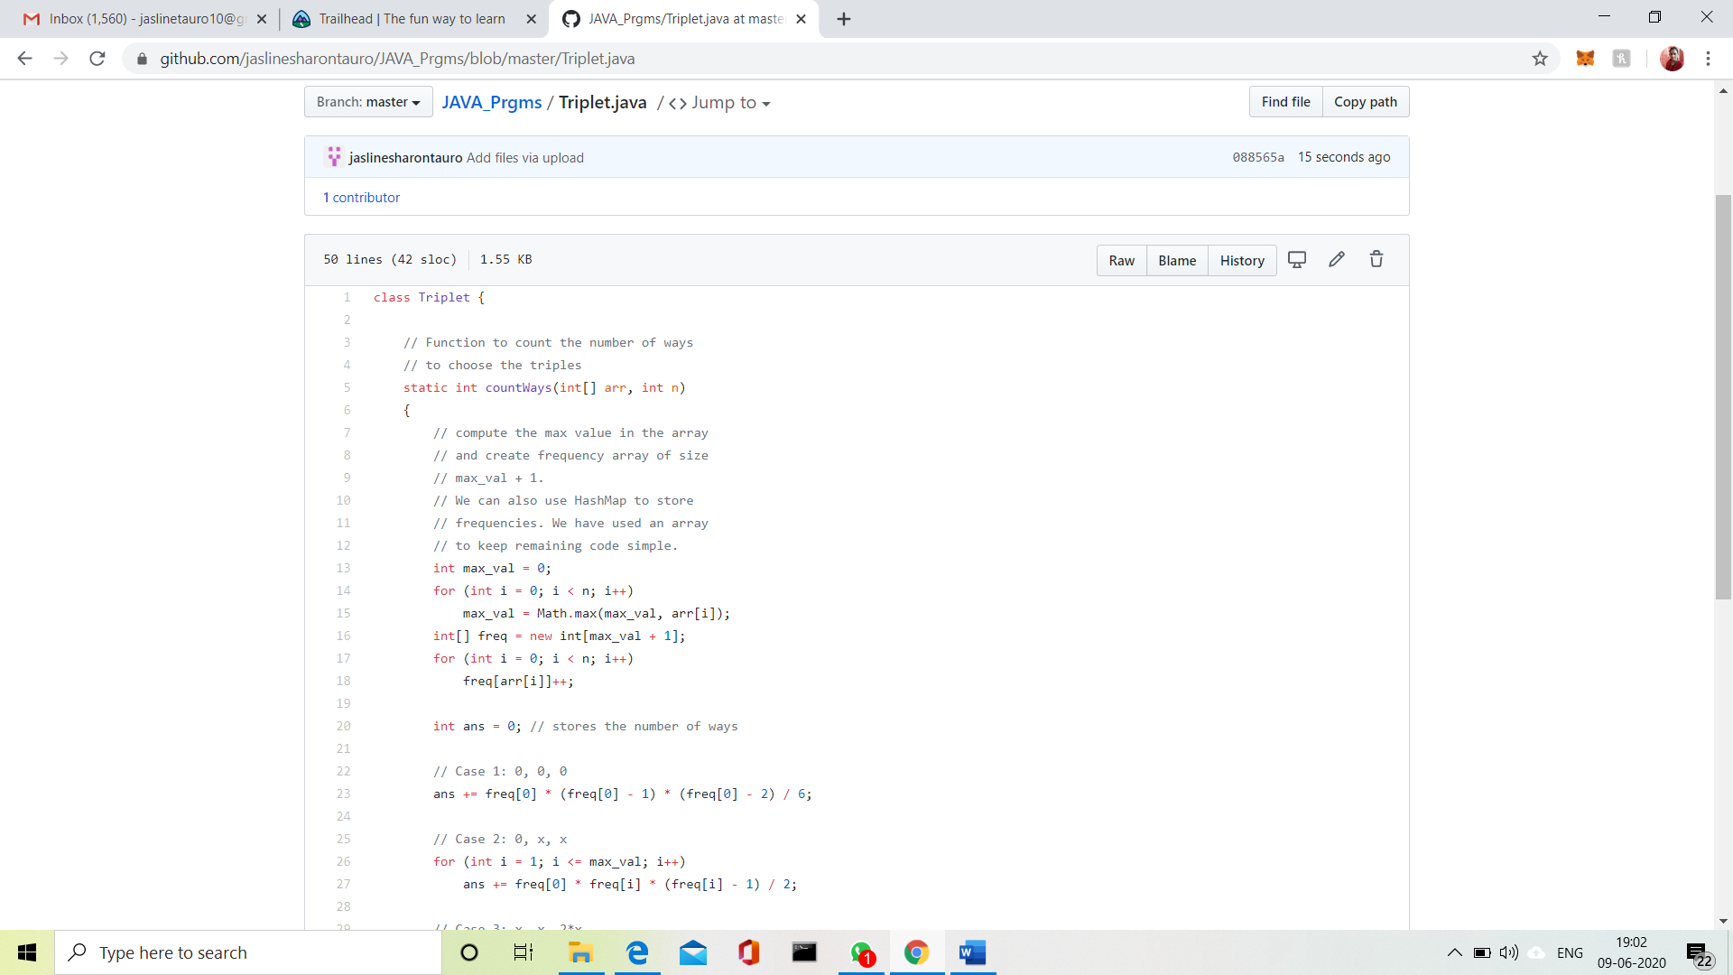

Input:  
The first line of input contains an integer T denoting the number of test cases. Then T test cases follow. Each test case consists of two lines. First line of each test case contains an Integer N denoting size of array and the second line contains N space separated elements.

Output:  
For each test case, print the count of all triplets, in new line. If no such triplets can form, print "-1".

Constraints:  
1 <= T <= 100  
3 <= N <= 105  
1 <= A[i] <= 106

**Example:**  
Input:  
4  
1 5 3 2

Output:  
2

Explanation:  
There are 2 triplets: 1 + 2 = 3 and 3 +2 = 5

**Problem Statement 2:**

Write a Java Program to find total number of subarrays which start and end with the same element.

Given an array A of size N where the array elements contain values from 1 to N with duplicates, the task is to find total number of subarrays which start and end with the same element.  
**Examples:**

Input: A[] = {1, 2, 1, 5, 2}  
Output: 7  
Explanation:  
Total 7 sub-array of the given array are {1}, {2}, {1}, {5}, {2}, {1, 2, 1} and {2, 1, 5, 2} are start and end with same element.

